A Weekend of Flamenco with MarijaTemo
Performance, Unique Workshops, and Private/Semi-Private/Coaching Instruction
(For Guitarists, Singers, and Dancers)
3/13-15, 2015
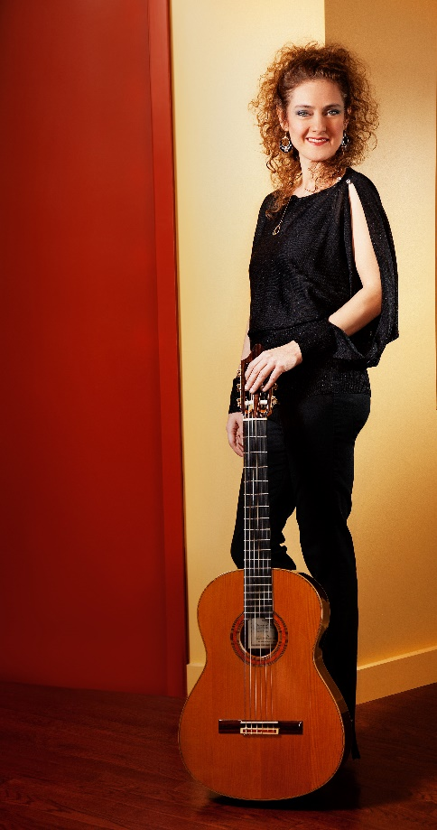
3/13/15 (Fri) Performance with Clinard Dance
Location: 1915 S. Halsted St.
Time: Performances at 7:30 and 9:00pm
*Free concert in conjunction with Chicago Arts District’s Second Friday Open Studio Series

3/14/15 (Sat.) Two Flamenco Workshops
Workshop 1:
Overview and Basic Application of Flamenco Forms (For all levels of Guitar Singing, and Dance)
Experience a workshop asking any questions and trying out the basics of the different flamenco forms. Guitarists: Learn strumming techniques on some flamenco forms. Singers: Try out vocal techniques on how to sound flamenco. Dancers: Learn the look and how to transmit the energy in your body with a few steps.

Time: 10:00- 11:30a.m.
Cost: $50
Workshop 2:
Flamenco Communication (For Guitarists, Singers, and Dancers of Int./Adv Level)
Specialized Interactive Workshop, created by Temo, (for Dancers, Guitarists, and Singers) on what is required from each of them to effectively communicate (interact, accompany, compliment, and improvise) with one another through a breakdown on the structure of flamenco dance and song forms. Sought after for her unique ability to teach all three of the flamenco genres (dance, guitar, and singing), Temo explains (through the use of graphic charts that she has devised) the underlying structure of complete flamenco dance and song forms, demonstrates important moments that need to be conveyed, and has participants try out the process. For more detailed info, visit: http://www.marijatemo.com/flamenco-communication-lessons/
Palo: Bulerias
Time: 11:45a.m.- 1:15p.m.
Cost: $50
Note: Participants are recommended to bring paper and pens as well their dance shoes, guitars, and capos. Audio recording allowed. Any video recording or internet posting must have Artist’s approval.

3/15/15 (Sun.) Privates/Semi-Privates/Coaching available with MarijaTemo
Private classes: $70 per hour
Semi-Privates: $60 per person per hour.
Coaching: $50 per person per hour.
(Coaching is for small groups containing one or more guitarists, dancers, and/or singers who have specific requests with their repertoire of dances, accompaniment, or singing regarding structure and communication.)

Location: Clinard Dance, 1747 S. Halsted Street, Rear Studio, Chicago, IL 60608
To Register: wendy@clinardance.org 312.399.1984
For more info on MarijaTemo visit www.marijatemo.com
Marija’s Communication Course was offered for 10 years consecutively at the University of New Mexico International Flamenco Festival, at the Toronto International Flamenco Festival, and reviewed in magazines such as Flamenco USA, Flamenco International (London, England), and Dance Magazine. Marija’s method continues to be in demand in the US and abroad.

